Ideation Phase
Define the Problem Statements

Date
Team ID | NM2025TMID02994
Project Name | LEASE MANAGEMENT
Maximum Marks

Customer Problem Statement – Lease Management
Customers (property owners, tenants, or leasing companies) face difficulties managing lease agreements efficiently. Current manual or outdated systems lead to errors, missed payments, poor visibility of lease terms, compliance issues, and time-consuming administrative work. They need a centralized, automated lease management solution that simplifies tracking, ensures compliance with accounting standards, sends alerts for renewals or expirations, and provides real-time financial insights.Businesses managing multiple leases often struggle with scattered data, manual tracking, and lack of visibility across their lease portfolio. Important dates like renewals, expirations, and rent escalations are easily missed, leading to financial losses and compliance risks. Without an integrated lease management system, reporting, forecasting, and decision-making become slow and inaccurate.
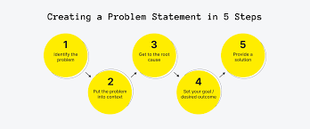

Example:
ABC Properties manages over 500 commercial leases using spreadsheets and email reminders. As the portfolio grows, the company faces challenges in tracking lease renewals, rent escalations, and maintenance schedules. Missed deadlines have led to renewal delays, lost revenue, and tenant dissatisfaction. The management team lacks real-time visibility into lease performance and compliance with accounting standards (like IFRS 16).
They need an automated lease management system that can centralize lease data, send alerts for key dates, generate compliance reports, and provide analytics for better decision-making.

